**E-COMMERCE**

By

Shivam Singh

**PROJECT REPORT**

Submitted as a training assignment

##### 

##### 

**ABSTRACT**

Electronic Commerce is process of doing business through computer networks. A person sitting on his chair in front of a computer can access all the facilities of the Internet to buy or sell the products. Unlike traditional commerce that is carried out physically with effort of a person to go & get products, ecommerce has made it easier for human to reduce physical work and to save time.

E-Commerce which was started in early 1990’s has taken a great leap in the world of computers, but the fact that has hindered the growth of e-commerce is security. Security is the challenge facing e-commerce today & there is still a lot of advancement made in the field of security. The main advantage of e-commerce over traditional commerce is the user can browse online shops, compare prices and order merchandise sitting at home on their PC. For increasing the use of e-commerce in developing countries the B2B e-commerce is implemented for improving access to global markets for firms in developing countries. For a developing country advancement in the field of e-commerce is essential. The research strategy shows the importance of the e-commerce in developing countries for business applications.

**Table of Contents**

1. Introduction
   1. AIM
   2. Need of the application
2. System Requirement Analysis
   1. Information Gathering
   2. System Feasibility
      1. Economic Feasibility
      2. Technical Feasibility
      3. Operational Feasibility
3. Modules
   * 1. Shop Products Module

3.1.2 Product Description Module

3.1.3 Cart Details Module

UML Diagrams

Use case Diagram

Class Diagram

Deployment Diagram

Package Diagram

1. Implementation
   1. Front end
   2. Back End
2. Testing
   1. Unit Testing

5.2 Integration Testing

5.3 Validation Testing

5.4 White Box Testing

5.4.1 Levels

5.4.2 Procedures

5.4.3 Advantage

5.4.4 Disadvantage

* 1. Black Box Testing
     1. Test Procedures
     2. Test Cases

5.6 System Testing

1. Challenges in India
2. Conclusions

# Introduction

**E-Commerce**

E-Commerce (Electronic Commerce) is process of doing business through computer networks. The primary goal of an e-commerce site is to sell goods and services online. Online shopping is a form of electronic shopping store where the buyer is directly online to the seller’s computer usually via the internet.

A person sitting on his chair in front of a computer can access all the facilities of the Internet to buy or sell the products. Online Shopping System helps in buying of goods, products and services online by choosing the listed products from website (E-Commerce site). The Shopping cart is mainly useful for who haven’t time to go to shopping. Shopping cart is a very important feature used in e-commerce to assist people making purchases online. The sale and purchase transaction is completed electronically and interactively in real-time. User can login into e-Commerce website, once he logged in then automatically one shopping cart will be created, once user select an item it will add to cart. In case user thinks the selected item is not useful for him, then he can delete that item form the cart. Report generation feature is provided using Crystal Reports to generate different kinds of reports like bar graphs, pie charts and table type charts etc.

## 1.1 AIM

The main aim of e-commerce websites development is to sell products to users. The most successful websites are carefully optimized to achieve a high percentage of purchases. To achieve success e-commerce websites need to integrate all of the latest online closing & upsell techniques available which have been proven to increase the chances that a visitor will purchase. There are many important elements that go into building a successful e-commerce website such as removing friction during the purchasing process, making the checkout smooth and easy, making the website fast and attractive, up selling users on related products, incentivizing buyers, reducing cart abandonment, nurturing past buyers to buy again, remarketing to past visitors who haven’t yet purchased, using the proper payment options, having a mobile ready design and many more things which are needed to develop and e-commerce website.

## 1.2 Need of the application

There are large numbers of commercial Online Shopping websites offering large number of products tailored to meet the shopping interests of large number of customers. These online marketplaces have thousands of products listed under various categories.

# 2. System Requirement Analysis

## 2.1 Information Gathering

As the goal of the application is ease of use and to provide an interactive interface, extensive research has been done to gain an insight into the needs and behaviours of various users. The working of the application is made convenient and easy to use for the end user. Dr Andresen, Associate Professor, CIS provided regular feedback on the project.

Users can be classified into two types based on their knowledge of the products that suit their needs. They can be classified as users who know about the product that would satisfy their needs and users who have to figure out the product that would satisfy their needs. Users who know about the product should be able to find the product easily with the click of a button. Such users can search for the product by using the product name as the search term. Users who have to figure out the product that would satisfy their needs could use a search term to find a list of products and then should be able to filter the results based on various parameters like product type, manufacturer, price range, platform supported etc.

The users should be able to view the complete specification of the product and various images at different Zoom levels. The user should be able to read the customer reviews for the product and the ratings provided. They should be able to write their own reviews. They should be able to print out the specifications for a product or email the product page to a friend etc.

To increase the ease of use the user should be able to add a product to the shopping cart by dragging a product and dropping it in the shopping cart. A user should able to edit the contents of a shopping cart. They should be able to update the quantities of the products added to the cart and remove the products from the cart. The user should be able to remove the product from the shopping cart by dragging the product and dropping it outside the cart.

The application can be made interactive by pop up messages when a product has been dropped in to the shopping cart or out of the shopping cart. The user can be notified if the cursor enters a drop area and the object that could be dropped. Also users are impatient making it important to load pages soon.

Other than this, I did a lot of research on various other methods of building this application which and was able to incorporate a few stronger features into the application.

## 2.2 System Feasibility

A feasibility study is a high-level capsule version of the entire System analysis and Design Process. The study begins by classifying the problem definition. Feasibility is to determine if it’s worth doing. Once an acceptance problem definition has been generated, the analyst develops a logical model of the system. A search for alternatives is analysed carefully. There are 3 parts in feasibility study.

The system feasibility can be divided into the following sections:

#### 2.2.1 Economic Feasibility

#### Establishing the cost-effectiveness of the proposed system i.e. if the benefits do not outweigh the costs then it is not worth going ahead. In the fast paced world today there is a great need of online social networking facilities. Thus the benefits of this project in the current scenario make it economically feasible. The purpose of the economic feasibility assessment is to determine the positive economic benefits to the organization that the proposed system will provide.It includes quantification and identification of all the benefits expected. This assessment typically involves a cost/benefits analysis.

##### This involves questions such as whether the technology needed for the system exists, how difficult it will be to build, and whether the firm has enough experience using that technology. The assessment is based on outline design of system requirements in terms of input, processes, output, fields, programs and procedures. This can be qualified in terms of volume of data, trends, frequency of updating in order to give an introduction to the technical system. The application is the fact that it has been developed on windows XP platform and a high configuration of 1GB RAM on Intel Pentium Dual core processor. This is technically feasible .The technical feasibility assessment is focused on gaining an understanding of the present technical resources of the organization and their applicability to the expected needs of the proposed system. It is an evaluation of the hardware and software and how it meets the need of the proposed system.

**2.2.2 OPERATIONAL FEASIBILITY**

Operational feasibility is the measure of how well a proposed system solves the problems, and takes advantage of the opportunities identified during scope definition and how it satisfies the requirements identified in the requirements analysis phase of system development. The operational feasibility assessment focuses on the degree to which the proposed development projects fits in with the existing business environment and objectives with regard to development schedule, delivery date, corporate culture and existing business process. To ensure success, desired operational outcomes must be imparted during design and development. These include such design-dependent parameters as reliability, maintainability, supportability, usability, producibility, disposability, sustainability, affordability and others. These parameters are required to be considered at the early stages of design if desired operational behaviours are to be realised. A system design and development requires appropriate and timely application of engineering and management efforts to meet the previously mentioned parameters.

#### 2.2.3 TECHNICAL FEASIBILITY

This involves questions such as whether the technology needed for the system exists, how difficult it will be to build, and whether the firm has enough experience using that technology. The assessment is based on outline design of system requirements in terms of input, processes, output, fields, programs and procedures. This can be qualified in terms of volume of data, trends, frequency of updating in order to give an introduction to the technical system. The application is the fact that it has been developed on windows XP platform and a high configuration of 1GB RAM on Intel Pentium Dual core processor. This is technically feasible .The technical feasibility assessment is focused on gaining an understanding of the present technical resources of the organization and their applicability to the expected needs of the proposed system.

# NUMBER OF MODULES OF e-Commerce WEBSITE MANAGEMENT SYSTEM

This project is divided into 9 modules:

1. Registration Module

2. Products Browse Module

3. Products Search Module

4. Shopping cart Module

5. Shipping & Billing Module

6. Payment Module

7. Admin User Management Module

8. Admin Catalog Management Module

9. Admin Order Management Module

#### 3.1 Shop Products Module

This module starts when the user visits the home page or when a user searches for a product by entering a search term. This part of the application includes displaying all the products that are available or the products that match the search term entered by the user. The user can then filter these products based on various parameters like manufacturer, product type, operating system supported or a price range. The user browse through the products and each product would be displayed with an image and its features like operating system supported, number of user licenses and if it is a full version or an upgrade version. A user can add a product to the cart either by dragging the product and dropping it in the cart or by clicking a button. The user would be able to see the shopping cart summary.

#### 3.2 Product Description Module

This module starts when a user visits the product description page. A user can view various images of the product of different sizes. The use can see an enlarged image in a popup window. The user can view the complete specification of the product like its features, operating system supported, system requirements etc. A user can also view the manufacturer information and also information about rebates, exchange policies etc. A user can also view the reviews of the product. A user can also write a review for the product.

#### 3.3 Shopping Cart Module

This module starts when the user views the shopping cart. All the products that have been added to the shopping cart by the user are listed along with their price and the quantity. The total price of all the products added to cart is displayed. A user can edit the quantity of each product or remove the product from the shopping cart. A user can remove the product from the cart by clicking a button or by dragging the product and dropping it outside the cart. The total price changes accordingly when a user edits the quantity of a product or when a product is removed from the cart.

**UML Diagrams**

**Use case Diagram**

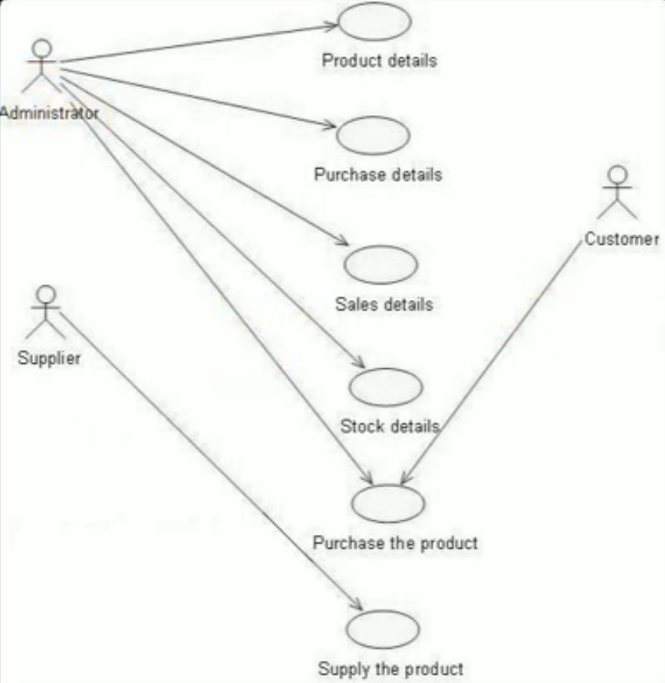

Class Diagram

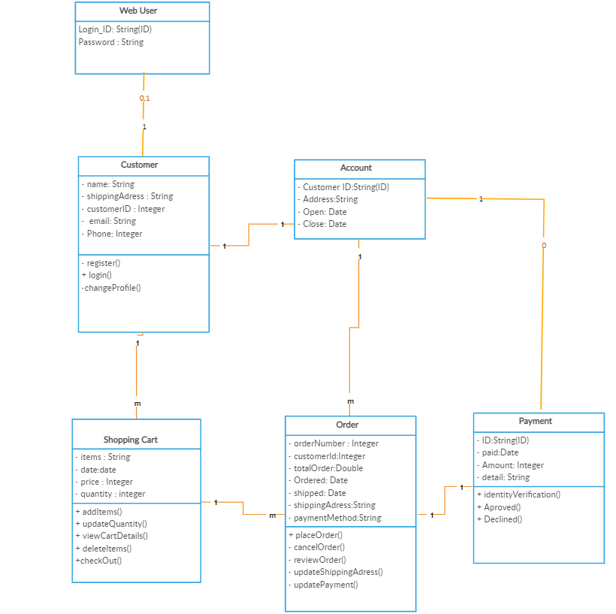

**Deployment Diagram**

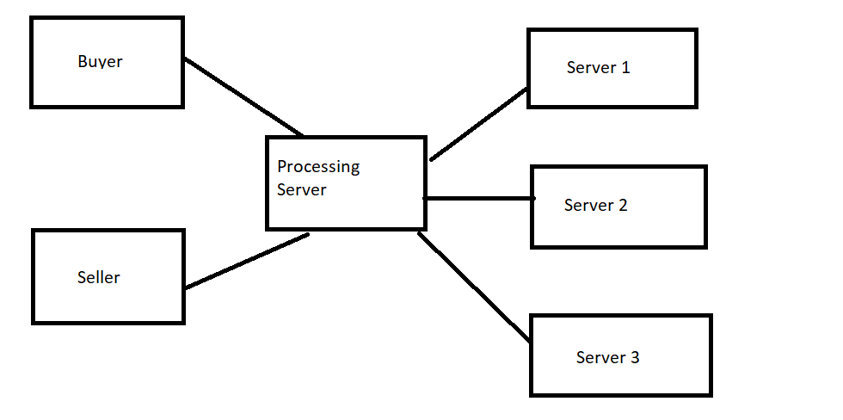

**Package Diagram**

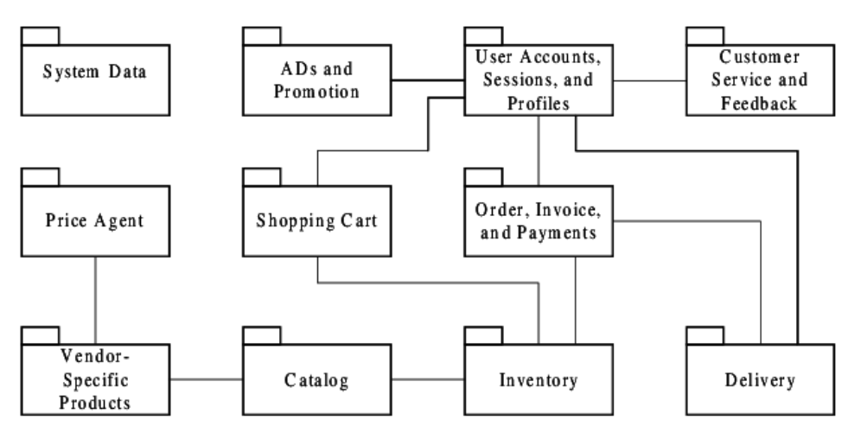

# Implementation

In this Section we will do Analysis of Technologies to use for implementing the project

**FRONT END**

**HTML**

Hypertext Markup Language (HTML) is the standard markup language for documents designed to be displayed in a web browser. It can be assisted by technologies such as Cascading Style Sheets (CSS) and scripting languages such as JavaScript. Web browsers receive HTML documents from a web server or from local storage and render the documents into multimedia web pages. HTML describes the structure of a web page semantically and originally included cues for the appearance of the document.

HTML elements are the building blocks of HTML pages. With HTML constructs, images and other objects such as interactive forms may be embedded into the rendered page. HTML provides a means to create structured documents by denoting structural semantics for text such as headings, paragraphs, lists, links, quotes and other items. HTML elements are delineated by tags, written using angle brackets. Tags such as <img /> and <input /> directly introduce content into the page. Other tags such as <p> surround and provide information about document text and may include other tags as sub-elements. Browsers do not display the HTML tags, but use them to interpret the content of the page.

**CSS**

Cascading Style Sheets (CSS) is a style sheet language used for describing the presentation of a document written in a markup language like HTML.CSS is a cornerstone technology of the World Wide Web, alongside HTML and JavaScript.CSS is designed to enable the separation of presentation and content, including layout, colors, and fonts. This separation can improve content accessibility, provide more flexibility and control in the specification of presentation characteristics, enable multiple web pages to share formatting by specifying the relevant CSS in a separate .css file, and reduce complexity and repetition in the structural content.

CSS information can be provided from various sources. These sources can be the web browser, the user and the author. The information from the author can be further classified into inline, media type, importance, selector specificity, rule order, inheritance and property definition. CSS style information can be in a separate document or it can be embedded into an HTML document. Multiple style sheets can be imported. Different styles can be applied depending on the output device being used; for example, the screen version can be quite different from the printed version, so that authors can tailor the presentation appropriately for each medium. The style sheet with the highest priority controls the content display. Declarations not set in the highest priority source are passed on to a source of lower priority, such as the user agent style. The process is called cascading.

**JavaScript**

JavaScript s a high-level, interpreted scripting language that conforms to the ECMA Script specification. JavaScript has curly-bracket syntax, dynamic typing, prototype-based object-orientation, and first-class functions. Alongside HTML and CSS, JavaScript is one of the core technologies of the World Wide Web.JavaScript enables interactive web pages and is an essential part of web applications. The vast majority of websites use it,and major web browsers have a dedicated JavaScript engine to execute it. As a multi-paradigm language, JavaScript supports event-driven, functional, and imperative (including object-oriented and prototype-based) programming styles. It has APIs for working with text, arrays, dates, regular expressions, and the DOM, but the language itself does not include any I/O, such as networking, storage, or graphics facilities. It relies upon the host environment in which it is embedded to provide these features.

Initially only implemented client-side in web browsers, JavaScript engines are now embedded in many other types of host software, including server-side in web servers and databases, and in non-web programs such as word processors and PDF software, and in runtime environments that make JavaScript available for writing mobile and desktop applications, including desktop widgets.

**BACK END**

**PHP**

PHP is a server side scripting language that is used to develop Static websites or Dynamic websites or Web applications. PHP stands for Hypertext Pre-processor, that earlier stood for Personal Home Pages. PHP scripts can only be interpreted on a server that has PHP installed. The client computers accessing the PHP scripts require a web browser only. A PHP file contains PHP tags and ends with the extension ".php".

The term PHP is an acronym for PHP: Hypertext Preprocessor. PHP is a server-side scripting language designed specifically for web development. PHP can be easily embedded in HTML files and HTML codes can also be written in a PHP file. The thing that differentiates PHP with client-side language like HTML is, PHP codes are executed on the server whereas HTML codes are directly rendered on the browser.

**MySQL**

MySQL is an open source relational database management system (RDBMS) based on Structured Query Language (SQL). It is one part of the very popular LAMP platform consisting of Linux, Apache, My SQL, and PHP. Currently My SQL is owned by Oracle. My SQL database is available on most important OS platforms. It runs on BSD Unix, Linux, Windows, or Mac OS. Wikipedia and YouTube use My SQL. These sites manage millions of queries each day. My SQL comes in two versions: My SQL server system and My SQL embedded system.

# 5. Testing

Software testing is a process of running with intent of finding errors in software. Software testing assures the quality of software and represents final review of other phases of software like specification, design, code generation etc.

## 5.1 Unit Testing

Unit testing emphasizes the verification effort on the smallest unit of software design i.e.; a software component or module. Unit testing is a dynamic method for verification, where program is actually compiled and executed. Unit testing is performed in parallel with the coding phase. Unit testing tests units or modules not the whole software.

I have tested each view/module of the application individually. As the modules were built up testing was carried out simultaneously, tracking out each and every kind of input and checking the corresponding output until module is working correctly.

The functionality of the modules was also tested as separate units. Each of the three modules was tested as separate units. In each module all the functionalities were tested in isolation.

In the Shop Products Module when a product has been added to cart it has been made sure that if the item already exists in the shopping cart then the quantity is increased by one else a new item is created in the shopping cart. Also the state of the system after a product has been dragged in to the shopping cart is same as the state of the system if it was added by clicking the add to cart button. Also it has been ensured that all the images of the products displayed in the shop products page are drag gable and have the product property so that they can be dropped in the cart area.

In the Product Description Module it has been tested that all the images are displayed properly. Users can add review and the as soon as a user adds a review it is updated in the view customer review tab. It has been checked to see if the whole page refreshes or a partial page update happens when a user writes a review.

In the Cart Details it has been tested that when a user edits a quantity or removes a product from the cart, the total price is updated accordingly. It has been checked to see if the whole page refreshes or a partial page update happens when a user edits the cart.

Visual Studio 2008 has in built support for testing the application. The unit testing can be done using visual studio 2008 without the need of any external application. Various methods have been created for the purpose of unit testing. Test cases are automatically generated for these methods. The tests run under the ASP.NET context which means settings from Web. config file are automatically picked up once the test case starts running.

Methods were written to retrieve all the manufacturers from the database, strings that match a certain search term, products that match certain filter criteria, all images that belong to a particular product etc. Unit test cases were automatically generated for these methods and it can be seen in figure 6.1 that the tests have passed.

## 5.2 Integration Testing

In integration testing a system consisting of different modules is tested for problems arising from component interaction. Integration testing should be developed from the system specification. Firstly, a minimum configuration must be integrated and tested.

It occurs after unit testing and before validation testing. Integration testing takes as its input modules that have been unit tested, groups them in larger aggregates, applies tests defined in an integration test plan to those aggregates, and delivers as its output the integrated system ready for system testing.

**Purpose**

The purpose of integration testing is to verify functional, performance, and reliability requirements placed on major design items. These "design items", i.e., assemblages (or groups of units), are exercised through their interfaces using black-box testing, success and error cases being simulated via appropriate parameter and data inputs. Simulated usage of shared data areas and inter-process communication is tested and individual subsystems are exercised through their input interface. Test cases are constructed to test whether all the components within assemblages interact correctly, for example across procedure calls or process activations, and this is done after testing individual modules, i.e., unit testing. The overall idea is a "building block" approach, in which verified assemblages are added to a verified base which is then used to support the integration testing of further assemblages. Software integration testing is performed according to the software development life cycle (SDLC) after module and functional tests. The cross-dependencies for software integration testing are: schedule for integration testing, strategy and selection of the tools used for integration, define the cyclomatical complexity of the software and software architecture, reusability of modules and life-cycle and versioning management. Some different types of integration testing are big-bang, top-down, and bottom-up, mixed (sandwich) and risky-hardest. Other Integration Patterns[2] are: collaboration integration, backbone integration, layer integration, client-server integration, distributed services integration and high-frequency integration

## 5.3 Validation Testing

It provides final assurances that software meets all functional, behavioral & performance requirement. Black box testing techniques are used.

There are three main components

* Validation test criteria (no. in place of no. & char in place of char)
* Configuration review (to ensure the completeness of s/w configuration.)
* Alpha & Beta testing-Alpha testing is done at developer’s site i.e. at home & Beta testing once it is deployed. Since I have not deployed my application, I could not do the Beta testing.

Test Cases- I have used a number of test cases for testing the product. There were different cases for which different inputs were used to check whether desired output is produced or not.

* 1. Addition of a new product to the cart should create a new row in the shopping cart.
  2. Addition of an existing product to the cart has to update the quantity of the product.
  3. Any changes to items in the cart have to update the summary correctly.
  4. Because same page is inserting data into more than one table in the database atomicity of the transaction is tested.
  5. The state of the system after a product has been dragged in to the cart should be same as the state of the system if the same product is added to the cart by clicking a button.

## 5.4 White Box Testing

White-box testing (also known as clear box testing, glass box testing, transparent box testing, and structural testing) is a method of testing software that tests internal structures or workings of an application, as opposed to its functionality (i.e. black-box testing). In white-box testing an internal perspective of the system, as well as programming skills, are used to design test cases. The tester chooses inputs to exercise paths through the code and determine the appropriate outputs. This is analogous to testing nodes in a circuit, e.g. in-circuit testing (ICT). White-box testing can be applied at the unit, integration and system levels of the software testing process. Although traditional testers tended to think of white-box testing as being done at the unit level, it is used for integration and system testing more frequently today. It can test paths within a unit, paths between units during integration, and between subsystems during a system–level test. Though this method of test design can uncover many errors or problems, it has the potential to miss unimplemented parts of the specification or missing requirements.

**5.4.1 Levels**

**1 ) Unit testing :**White-box testing is done during unit testing to ensure that the code is working as intended, before any integration happens with previously tested code. White-box testing during unit testing catches any defects early on and aids in any defects that happen later on after the code is integrated with the rest of the application and therefore prevents any type of errors later on.

**2 ) Integration testing :**White-box testing at this level are written to test the interactions of each interface with each other. The Unit level testing made sure that each code was tested and working accordingly in an isolated environment and integration examines the correctness of the behaviour in an open environment through the use of white-box testing for any interactions of interfaces that are known to the programmer.

**3 ) Regression testing :**White-box testing during regression testing is the use of recycled white-box test cases at the unit and integration testing levels.

**5.4.2 Procedures**

White-box testing's basic procedures involves the tester having a deep level of understanding of the source code being tested. The programmer must have a deep understanding of the application to know what kinds of test cases to create so that every visible path is exercised for testing. Once the source code is understood then the source code can be analyzed for test cases to be created. These are the three basic steps that white-box testing takes in order to create test cases:

* Input involves different types of requirements, functional specifications, detailed designing of documents, proper source code, security specifications. This is the preparation stage of white-box testing to layout all of the basic information.
* Processing involves performing risk analysis to guide whole testing process, proper test plan, execute test cases and communicate results. This is the phase of building test cases to make sure they thoroughly test the application the given results are recorded accordingly.
* Output involves preparing final report that encompasses all of the above preparations and results.

**5.4.3 Advantages**

White-box testing is one of the two biggest testing methodologies used today. It has several major advantages:

* Side effects of having the knowledge of the source code is beneficial to thorough testing.
* Optimization of code by revealing hidden errors and being able to remove these possible defects.
* Gives the programmer introspection because developers carefully describe any new implementation.
* Provides traceability of tests from the source, allowing future changes to the software to be easily captured in changes to the tests.
* White box testing give clear, engineering-based, rules for when to stop testing.

**5.4.4 Disadvantages**

Although white-box testing has great advantages, it is not perfect and contains some disadvantages:

* White-box testing brings complexity to testing because the tester must have knowledge of the program, including being a programmer. White-box testing requires a programmer with a high level of knowledge due to the complexity of the level of testing that needs to be done.
* On some occasions, it is not realistic to be able to test every single existing condition of the application and some conditions will be untested.
* The tests focus on the software as it exists, and missing functionality may not be discovered.

**5.5 : Black-Box Testing**

Black-box testing is a method of software testing that examines the functionality of an application without peering into its internal structures or workings. This method of test can be applied virtually to every level of software testing: unit, integration, system and acceptance. It typically comprises most if not all higher level testing, but can also dominate unit testing as well.

**5.5.1 Test Procedures**

Specific knowledge of the application's code/internal structure and programming knowledge in general is not required. The tester is aware of what the software is supposed to do but is not aware of how it does it. For instance, the tester is aware that a particular input returns a certain, invariable output but is not aware of how the software produces the output in the first place.

**5.5.2 Test Cases**

Test cases are built around specifications and requirements, i.e., what the application is supposed to do. Test cases are generally derived from external descriptions of the software, including specifications, requirements and design parameters. Although the tests used are primarily functional in nature, non-functional tests may also be used. The test designer selects both valid and invalid inputs and determines the correct output, often with the help of an oracle or a previous result that is known to be good, without any knowledge of the test object's internal structure.

**5.6 : SYSTEM TESTING**

System testing of software or hardware is testing conducted on a complete, integrated system to evaluate the system's compliance with its specified requirements. System testing falls within the scope of black-box testing, and as such, should require no knowledge of the inner design of the code or logic. As a rule, system testing takes, as its input, all of the "integrated" software components that have passed integration testing and also the software system itself integrated with any applicable hardware system(s). The purpose of integration testing is to detect any inconsistencies between the software units that are integrated together (called assemblages) or between any of the assemblages and the hardware. System testing is a more limited type of testing; it seeks to detect defects both within the "inter-assemblages" and also within the system as a whole.

System testing is performed on the entire system in the context of a Functional Requirement Specification(s) (FRS) and/or a System Requirement Specification (SRS). System testing tests not only the design, but also the behavior and even the believed expectations of the customer. It is also intended to test up to and beyond the bounds defined in the software/hardware requirements specification(s).

## 6. Challenges in India

India has less credit card population, lack of fast postal services in rural India. Accessing the Internet is currently hindered down by slow transmission speeds, frequent disconnects, cost of Wireless connection and wireless communication standards over which data is transmitted. High-speed-bandwidth Internet connection not available to most citizens of the nation at an affordable rate. In India, mostly people are not aware about the English language or not so good in English language. So that for the transaction over internet through electronic devices, language becomes one of the major factors to purchases, hire and sell a particular product or services. Multiple issues of trust in e-commerce technology and lack of widely accepted standards, lack of payment gateways, privacy of personal and business data connected over the Internet not assured security and confidentiality of data not in place to deploy ubiquitous IT Infrastructure and its maintenance

# 7. Conclusions

Growth of e-commerce depend to a great extent on effective IT security systems for which necessary technological and legal provisions need to be put in place and strengthened constantly. While many companies, organizations, and communities in India are beginning to take advantage of the potential of e-commerce, critical challenges remain to be overcome before e-commerce would become an asset for common people. With the explosion of internet connectivity through mobile devices like Smartphone and tablets, millions of consumers are making decisions online and in this way enterprises can build the brand digitally and enhance productivity but government policies must ensure the cost effective methods/solutions. Ecommerce in India is destined to grow both in revenue and geographic reach. The challenge of establishing consumer trust in e-commerce poses problems and issues that need further research.